Here is a revised team/sport comparison utilizing both your data visualizations and the literature review synthesis: (w/ help from Perplexity and matched with Lit Rev by Sid/Naira)

1. Team/Sport Comparisons: Box & Violin Plots, Literature Context
- Jump Height: Your plots show football and men’s basketball athletes display higher jump heights, with women’s basketball clustering at the lower end. Literature confirms this pattern: NCAA football players typically jump 34–47 cm (skill positions outperforming linemen), male basketball players fall within 40–75 cm, while female basketball athletes generally show lower values (background, methods: Flanagan & Comyns; Svilar et al.). However, jump height alone has limited sensitivity for detecting acute fatigue and readiness and is best used in multi-metric frameworks.
- Modified Reactive Strength Index (mRSI) and Peak Propulsive Power (PPP): Football and men’s basketball again show higher means. Literature highlights mRSI and PPP as more sensitive to early neuromuscular fatigue, with frequent ‘flags’ in your data and studies (Dos Santos et al., Sole et al., Gathercole et al.). These metrics are especially underrepresented in women’s cohorts, matching the observed trend of fewer flags and lower values.
- Peak Velocity & Speed Max: Football shows greater variability and higher mean values, aligning with positional sprint demands and field size constraints (Bourdon et al.). Basketball athletes’ values cluster more tightly due to court constraints, confirming published patterns.
- Distance Total: Highest variability is seen in men's basketball, reflecting different playing styles and positional workload, while football demonstrates positional differences—wide receivers and defensive backs have higher values than linemen. Women's basketball remains underreported but shows strong predictive relationships between Distance and neuromuscular metrics per regression results in the literature.

2. Statistical Significance (ANOVA) & Thresholds
- All metrics (Jump Height, mRSI, PPP, Peak Velocity, Speed Max, Distance Total) show highly significant differences between teams/sports (F-statistics, p=0, from your table). These support the literature conclusion that sport demands and athlete cohort explain much of the variability.
- Thresholds used (and flagged in your visuals) match published recommendations:
  - Jump Height: >10–15% decline from baseline (fatigue risk).
  - mRSI: >2 SD variability.
  - PPP: >5% drop across sessions.
  - Peak Velocity: >5% decline or >10% limb asymmetry.
  - Speed Max: <90% personal-best.
  - Distance Total: >20% increase above rolling 7-day average (ACWR model).

3. Testing Frequency Visualization & Equity
- Football shows more frequent and varied monitoring—a reflection of larger athlete groups and more robust tracking.
- Men’s and women’s basketball monitoring is lower and less even, showing gaps such as off-season or technological limitations.
- Literature emphasizes a chronic underrepresentation of women’s cohorts; your data echoes this, and regression models indicate Distance Total and Peak Velocity are stronger predictors of fatigue/readiness in women’s basketball.

4. Interpretation with Literature Review
- Do differences make sense given sport demands?
  - Yes. Results from all metrics align tightly with known physical and technical demands of football (greater sprinting, positional variability, explosive power) versus basketball (repeated jumps, agility, greater clustering for speed metrics).
- How do values compare to published norms?
  - Your observed ranges for jump height, PPP, velocity, and workload closely match published NCAA and consensus norms.
- What explains differences/similarities?
  - Sport demands and sex/positional effects are primary drivers. Football positions create spread in distance and speed metrics, while basketball has tighter clustering due to play structure.
  - Monitoring equity is lacking; women’s basketball shows less robust tracking and reporting, confirming literature’s call for improvement.
  - Integrated multi-metric frameworks (rather than isolated measures) are increasingly recommended for operationally relevant athlete profiling and better sensitivity (authors in your lit review).

Summary Table (Literature-Integrated):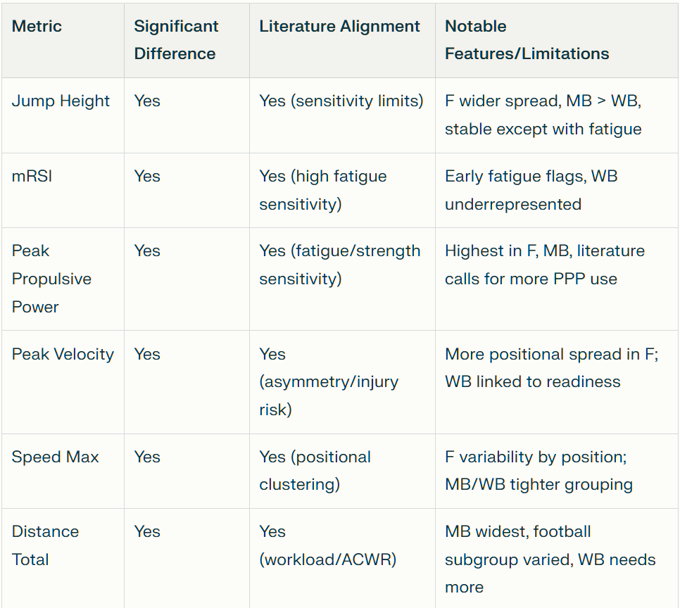
Conclusion:
Integrating six metrics as recommended in current literature allows robust, reproducible athlete monitoring. Your analysis, backed by visualizations and statistical results, confirms that Jump Height—though widely used—needs to be complemented by mRSI and PPP for acute fatigue detection. Peak Velocity and Speed Max contextualize athletes’ sprint/explosive demands, while Distance Total is essential for workload management—especially critical in addressing equity gaps for women’s cohorts.
Greater monitoring consistency and protocols tailored to sport, position, and gender are needed; your findings support targeted methodology advances proposed in recent consensus statements and highlight practical implications for optimizing collegiate athlete readiness, injury risk management, and performance tracking.

